

**Module Code & Module Title**

**CC4058NI Introduction to Information Systems**

**Assessment Weightage & Type**

**40% Individual Coursework**

**Year and Semester**

**2021-22 Spring**

**Student Name: Aman Shah**

**Group: N7**

**College ID: NP01NT4S220025**

**London Met ID: 22015828**

**Assignment Due Date: 1st June 2022**

**Assignment Submission Date: 31th May 2022**

*I confirm that I understand my coursework needs to be submitted online via Google Classroom under the relevant module page before the deadline for my assignment to be accepted and marked. I am fully aware that late submissions will be treated as non-submission and marks of zero will be awarded.*

Table of Contents

**1. Introduction** 1

1.1 Project Description 2

1.2 Goals of the Project. 3

1.3 Objectives of the Project. 3

1.4 Technology used to create the website. 4

1.5 Conclusion 5

**2. Discussion and Analysis** 7

2.1 Visual Studio Code 7

2.2 Wireframe 8

2.3 Home Page 9

2.4 Product Page 12

2.5 Single Product Page 15

2.6 Blog Page 18

2.7 Research page 21

2.8 Contact Us page 24

2.9 Cart page 27

**3. Testing** 30

3.1 Test 1 30

3.2 Test 2 31

3.3 Test 3 33

3.4 Test 4 35

3.5 Test 5 37

**4. Conclusion** 40

**Appendix** 41

**References** 42

**List of Figures**

Figure 1 HTML, CSS and JavaScript example. 6

Figure 2 Wireframe of the Homepage 10

Figure 3 Screenshot of Home Page 11

Figure 4 Wireframe of the Product page 13

Figure 5 Screenshot of Product Page 14

Figure 6 Wireframe of Single product page 16

Figure 7 Screenshot of Single product page 17

Figure 8 Wireframe of the Blog page 19

Figure 9 Screenshot of the Blog page 20

Figure 10 Wireframe of the Research page 22

Figure 11 Screenshot of the Research page 23

Figure 12 Wireframe of the Contact Us page 25

Figure 13 Screenshot of the Contact Us page 26

Figure 14 Wireframe of The Cart page 28

Figure 15 Screenshot of the Cart page 29

Figure 16 Screenshot of testing the date and time 30

Figure 17 Screenshot of the main image of the Single product page 31

Figure 18 Screenshot of Change in the main image of Single product page 32

Figure 19 Screenshot of filling up the form. 33

Figure 20 Screenshot of alert message. 34

Figure 21 Screenshot of the navigation bar of the home page 35

Figure 22 Screenshot of hover effect navigation bar 36

Figure 23 Screenshot of the navigation bar on the Blog page 36

Figure 24 Screenshot of clicking the product page 37

Figure 25 Screenshot of redirected to the product page 38

Figure 26 Screenshot of clicking the Facebook image at the footer section 38

Figure 27 Screenshot of redirected to the Facebook 39

Figure 28 Originality Test 41

**List of Table**

Table 1 Test 1 30

Table 2 Test 2 31

Table 3 Test 3 33

Table 4 Test 4 35

Table 5 Test 5 37

# **1. Introduction**

A website is a collection of publicly accessible, interlinked Web pages that share a single domain name (Techopedia, 2020). Websites can be created and maintained by an individual, group, business, or organization to serve a variety of purposes (Techopedia, 2020). The website’s web pages are linked with hyperlinks and hypertext and share a common interface and design (Geeksforgeeks, 2021). The website might also contain some additional documents and files such as images, videos, or other digital assets (Geeksforgeeks, 2021). There are different types of websites on the whole internet

some of the common types of websites are:

* **Blogs**: These types of websites cover any topics — they can give you fashion tips, music tips, travel tips, or fitness tips, nowadays professional blogging has become an external popular way of earning money online (Geeksforgeeks, 2021).
* **E-commerce**: These websites are well known as online shops, these websites allow us to make purchasing products and online payments for products and services and stores can be handled and operated on websites (Geeksforgeeks, 2021).
* **News and Magazines:**These websites need less explanation, the main purpose of these types of websites is to keep their readers up-to-date on current affairs whereas magazines focus on entertainment (Geeksforgeeks, 2021).
* **Social Media:**We all know about some famous social media websites like Facebook, Twitter, Reddit, and many more (Geeksforgeeks, 2021). These websites are usually created to let people share their thoughts, images, videos, and other useful components (Geeksforgeeks, 2021).
* **Educational:**Educational websites are quite simple to understand as their name itself explains them (Geeksforgeeks, 2021). These websites are designed to display information via audio or videos or images (Geeksforgeeks, 2021). For example, W3school, and JavaTpoint are some examples.

## 1.1 Project Description

Today with the advent of the internet, the world has become a smaller place. Any kind of information is easily available and at our fingertips (VelocityConsultancy, 2021). The world of the internet is amazing and it continues to transform our lives, the way we communicate, the way we receive and share information, and live a quality life (VelocityConsultancy, 2021).

I have created an e-commerce website for a store that sells iPhones at their local level and wants to expand its business online. The e-commerce website is necessary for the shore to make their brand awareness and showcase their brand to prospective customers. It will help the store to establish its image by letting the customer know who they are and what they are representing. One of the most prior reasons to have their website built is that it can help generate more leads and increase sales. The e-commerce website is the best way for a consumer to gather information about a business and what they are offering, it will also help them to get contact details of the business from the website. The website will help to improve the customer experience for example business frequently receives calls from prospective or existing customers to get information about the address or hours of the operation time, the minor details in the website will help them to get the information which will help to improve the customer experience. It will help to expand their business through digital marketing. The website has a blog and research section where I have described how technology has affected us in our daily life. And a research section where I have compared similarities from the different websites from which I have taken references. I have the aim to help them market their products and services to make their brand known widely with the help of the website I have developed.

## 1.2 Goals of the Project.

The goals of the project are:

* Improving website traffic.
* Growing their products.
* Providing personalized visitor experience
* To provide proper content
* Increasing sales

## 1.3 Objectives of the Project.

The objectives of the project are:

* Manage Online Selling Costs in A Strategic Way.
* Expanding their business.
* Providing a unique customer experience.
* Improving customer loyalty.
* To get information about their store easily online.
* Helps to identify the right target audiences.
* To increase their sales.
* Make the website responsive.
* Reducing cost-to-service.
* To reach the maximum number of customers at the right time.

## 1.4 Technology used to create the website.

A programming language is our way of communicating with software (Cox, 2021). The people who use programming languages are often called programmers or developers (Cox, 2021). The things we tell software using a programming language could be to make a webpage look a certain way or to make an object on the page move if the human user takes a certain action (Cox, 2021).

So, when a web designer is given an end goal like "create a webpage that has this header, this font, these colors, these pictures, and an animated unicorn walking across the screen when users click on this button," the web designer's job is to take that big idea and break it apart into tiny pieces, and then translate these pieces into instructions that the computer can understand -- including putting all these instructions in the correct order or syntax (Cox, 2021). The programming language used to create the website are HTML (HyperText Mark-up Language), CSS(Cascading Style Sheets), and JavaScript.

* **HTML**: HTML is at the core of every web page, regardless of the complexity of a site or the number of technologies involved (Cox, 2021). It's an essential skill for any web professional (Cox, 2021). It's the starting point for anyone learning how to create content for the web. And, luckily for us, it's surprisingly easy to learn (Cox, 2021).
* **CSS**: This programming language dictates how the HTML elements of a website should appear on the front of the page (Cox, 2021). It helps in the designing of the website.
* **JavaScript**: JavaScript is a logic-based programming language that can be used to modify website content and make it behave in different ways in response to a user's actions (Cox, 2021). Common uses for JavaScript include confirmation boxes, calls-to-action, and adding new identities to existing information (Cox, 2021).

## 1.5 Conclusion

A website is a collection of publicly accessible, interlinked Web pages that share a single domain name (Techopedia, 2020). Websites can be created and maintained by an individual, group, business, or organization to serve a variety of purposes (Techopedia, 2020). There are different types of websites on the whole internet

some of the common types of websites are:

* Blogs
* Ecommerce
* News and magazines
* Social media
* Educational

**Goals of the Project**.

The goals of the project are:

* Improving website traffic.
* Growing their products.
* Providing personalized visitor experience
* To provide proper content
* Increasing sales

To develop a website, we need three programming languages they are:

* HTML – HTML is used for defining the layout of a page a bare bone page structure.
* CSS – CSS is used to add styling to the bare bone page created using HTML.
* JavaScript – It is used to program logic for the page layout.

**A beautiful analogy**

We can say that the HTML is the metal frame of a vehicle that will help to design the layout of different parts of the vehicle. The CSS to be the vehicle color, decoration which will help to make the vehicle look more attractive, and JavaScript to be the engine of the vehicle. With the help of the frame, design, and engine we can properly drive the vehicle.

So the HTML, CSS, and JavaScript we can design a website.

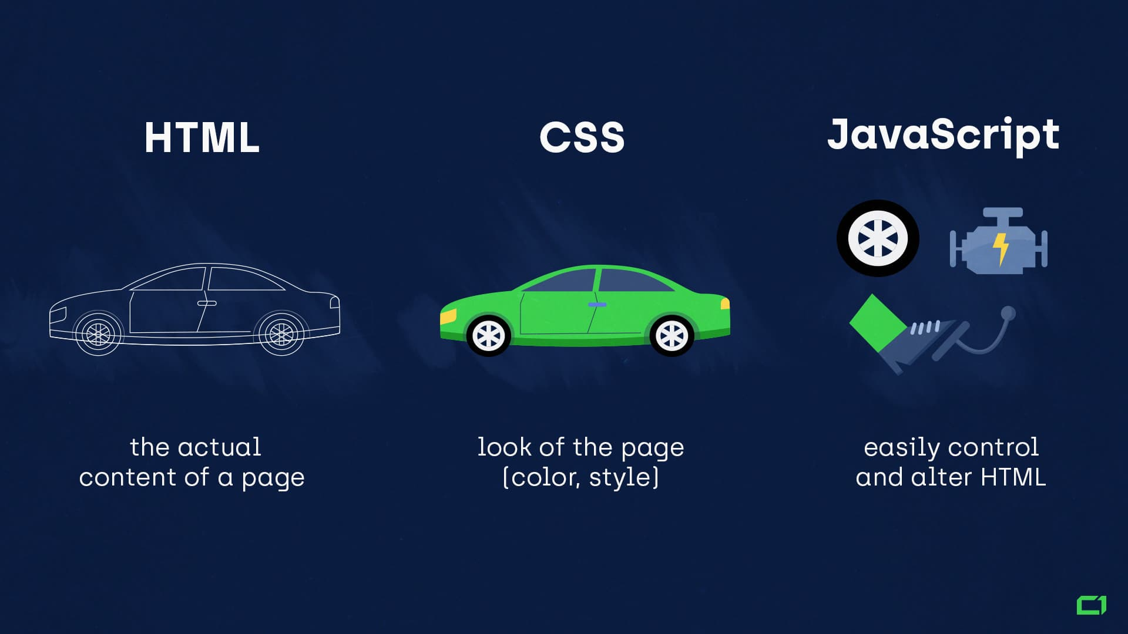

Figure 1 HTML, CSS and JavaScript example.

# **2. Discussion and Analysis**

A text editor is a computer program that lets a user enter, change, store, and usually print text (characters and numbers, each encoded by the computer and its input and output devices, arranged to have meaning to users or other programs) (TechTarget, 2022). Some of the popular text editors are Notepad, Notepad++, Sublime Text, and visual studio code. I have chosen Visual Studio Code.

## 2.1 Visual Studio Code

Visual Studio Code is a lightweight but powerful source code editor which runs on your desktop and is available for Windows, macOS, and Linux (Visual Studio Code, 2022). It comes with built-in support for JavaScript, Typescript, and Node.js and has a rich ecosystem of extensions for other languages (such as C++, C#, Java, Python, PHP, Go, HTML, CSS) and runtimes (such as .NET and Unity) (Visual Studio Code, 2022).

With advancements in technology day by day, Visual Studio Code is going to play a pivotal role in the development of software (Pedamkar, 2019). With its ever-evolving features and soon-to-be-added new settings, which will enable users to work with it from anywhere, it is certainly “THE THING” to keep one ahead of everyone in this ever-increasing IT market (Pedamkar, 2019).

The Advantages of using Vs Code are:

* Cross-platform support (Windows, Mac, Linux)
* Light-weight code editor
* Emmet
* Easy to add extension
* Freeware: Free of Cost- probably the best feature of all for all the programmers out there, even more for the organizations (Pedamkar, 2019).
* Many users will use it or might have used it for desktop applications only, but it also provides great tool support for Web Technologies like; HTML, CSS, and JSON (Pedamkar, 2019).

## 2.2 Wireframe

A wireframe is a two-dimensional skeletal outline of a webpage or app (HANNAH, 2021). Wireframes provide a clear overview of the page structure, layout, information architecture, user flow, functionality, and intended behaviors (HANNAH, 2021). As a wireframe usually represents the initial product concept, styling, color, and graphics are kept to a minimum (HANNAH, 2021). Some of the examples of tools used to create wireframes are Sketch, Adobe XD, Figma, and Balsamiq. I have chosen Balsamiq for this coursework.

Wireframes can be drawn by hand or created digitally, depending on how much detail is required (HANNAH, 2021). Wireframing is a practice most commonly used by UX designers (HANNAH, 2021). This process allows all stakeholders to agree on where the information will be placed before the developers build the interface out with code (HANNAH, 2021).

The tool used to create a wireframe for this coursework is called Balsamiq. Balsamiq Wireframes is a rapid low-fidelity UI wireframing tool that reproduces the experience of sketching on a notepad or whiteboard but using a computer (Balsamiq, 2022). It forces you to focus on structure and content, avoiding lengthy discussions about colors and details that should come later in the process (Balsamiq, 2022). The Balsamiq software is very helpful to develop the wireframe as it has a different kind of tools and icons which is very useful and help to create an amazing wireframe.

## 2.3 Home Page

A home page is a webpage that serves as the starting point of a website (Sharpened Productions, 2022). It is the default webpage that loads when you visit a web address that only contains a domain name (Sharpened Productions, 2022). The home page is at the start of the website. Most web servers allow your home page to contain one of several different filenames. An example is index.html.

The home page of my website has a navigation bar which is helpful to go from one page to another page. The website name is the iPhone as it sells different kinds of apple products. The homepage has a background image of the newest iPhone in which there is a button that helps us to be redirected to the product web page. Below the image, there is a services section of the company which will help the customer to know what services the brand offers to them. Below that, we have a just for you section where we have displayed the favorite product that customers have liked the most. And below that, we have the new arrivals section where we have displayed the new iPhone which has come to the store. Below that we have a banner section where we have displayed some motivation lines for the iPhones. Below that, I have added a date and time. After that, we have a newsletter area where the customer can fill the form with their email so they get the new product arrival message the first. After that, we have a footer section where I have included various links and copyright

Details also.

For the development of the homepage, I have first designed our wireframe and made the website. In the code, we have divided it into many sections and div tags.

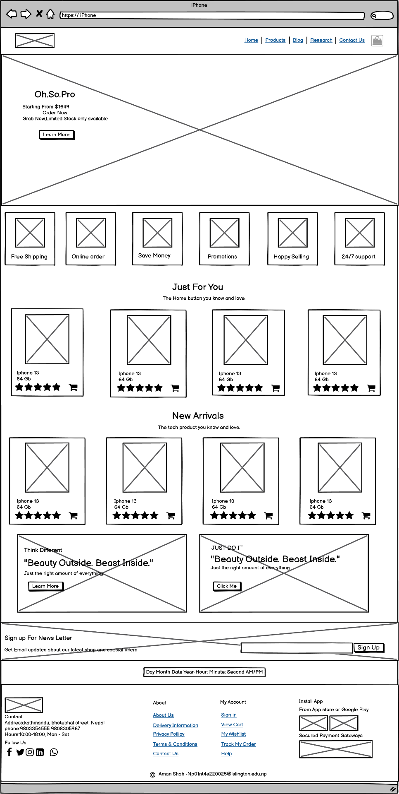

Figure 2 Wireframe of the Homepage

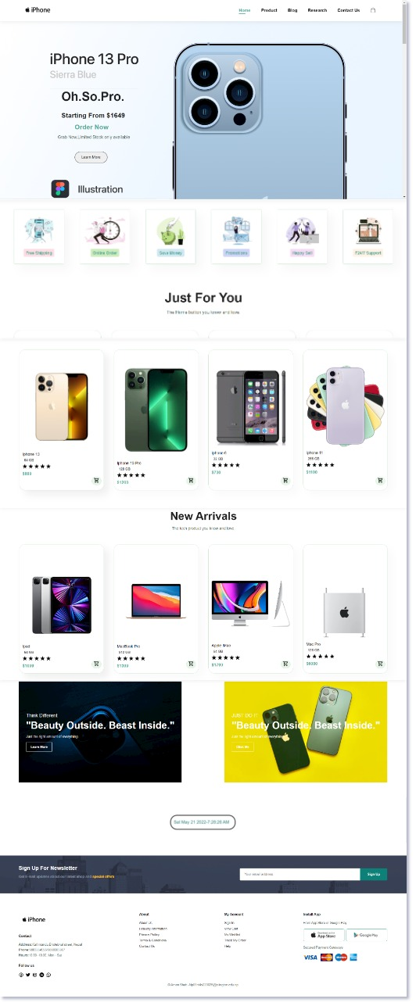

Figure 3 Screenshot of Home Page

## 2.4 Product Page

A product page is a page on a website that shows different kinds of products available in the store. This can include all kinds of products available in their store. While the text and image are shown on the page of different kinds of products.

The Product page of my website has a navigation bar which is helpful to go from one page to another page. The page has a banner that has a motive for choosing the iPhone. Below the banner, I have displayed all kinds of products that are available in the store with the price and rating, and name and add to cart option. The product is displayed four in a row which helps the image of the product more attractive to the customer. I have displayed five columns of products. After that, we have a newsletter area where the customer can fill the form with their email so they get the new product arrival message the first. After that, we have a footer section where I have included various links and copyright details also. The product page is divided into many sections and last, all the sections are described to be flex properties, which will help in making the website responsive for different screen devices.

For the development of the product page, I have first designed our wireframe and made the website.

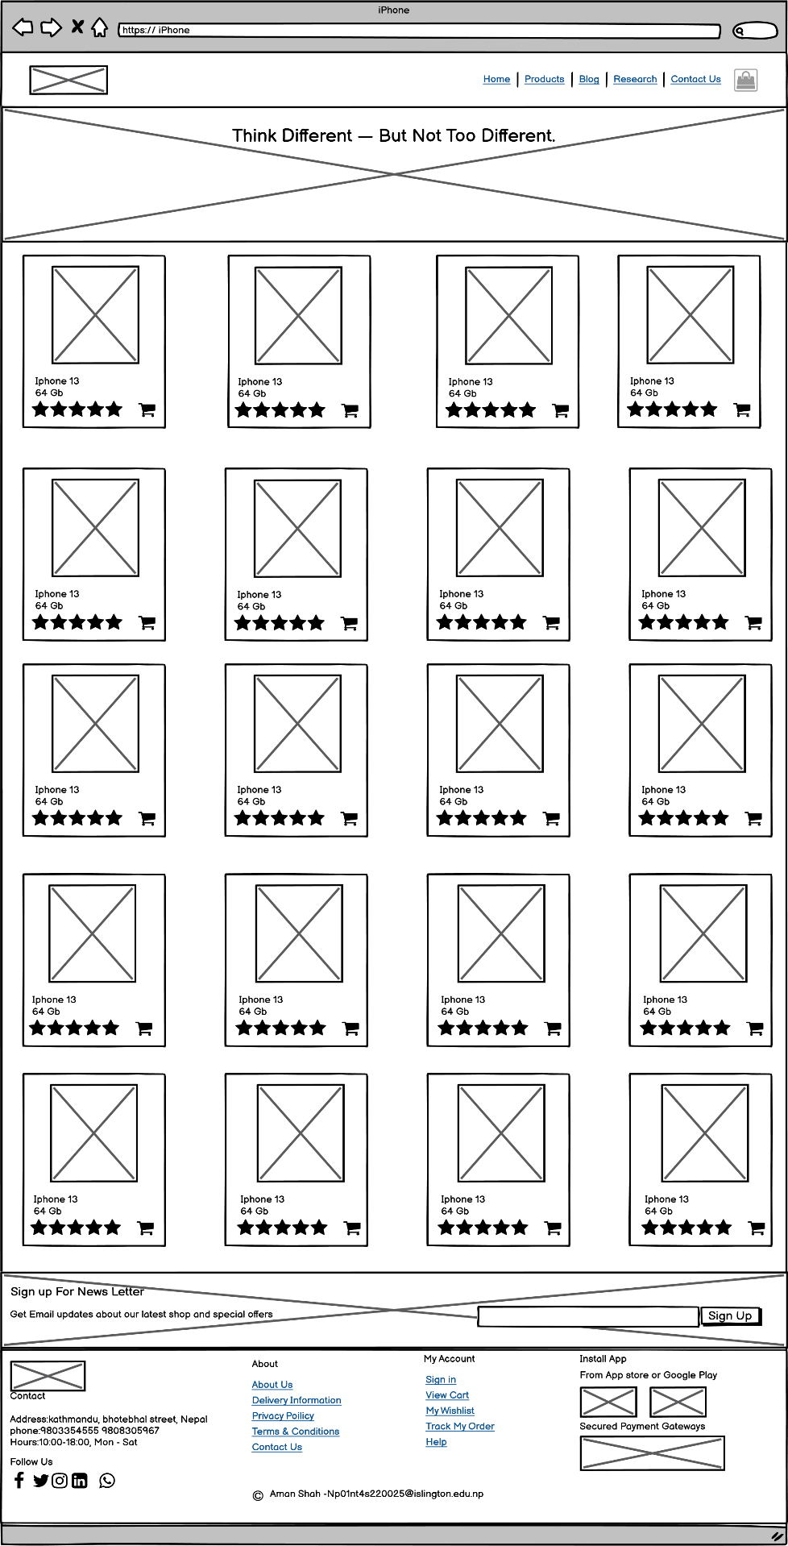

Figure 4 Wireframe of the Product page

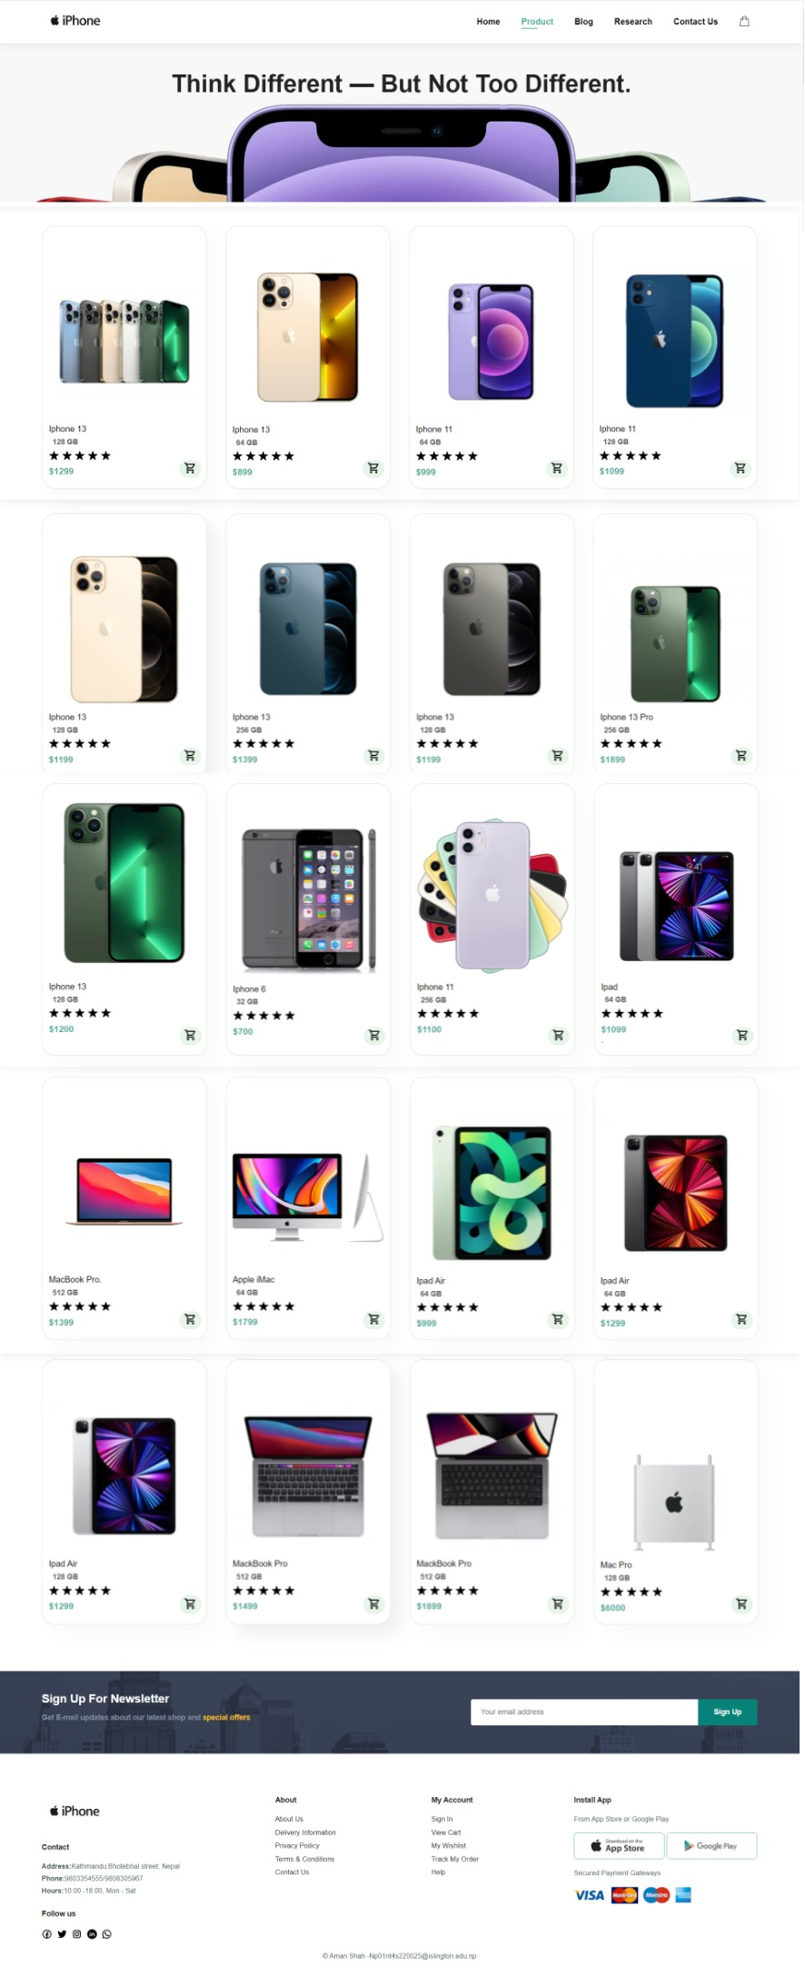

Figure 5 Screenshot of Product Page

## 2.5 Single Product Page

A Single product page is what defines the features, manufacturer, uses, and a lot more, about a single product. It is a page on an e-commerce website that defines a product in its entirety of which company, brand, and details about the product. This allows the users to know deeply about the product and how it will benefit them once they buy it.

The Single product page of my website has a navigation bar which is helpful to go from one page to another page. The page has a main image which is showcasing the product. And when we click the bottom smaller image it becomes the main image due to the use of JavaScript. There is a color selector which helps select the color of the product which they are going to choose. There is a paragraph about the product which describes the product and its properties. There is a Buy now option and a quantity selector also. Below that there is a feature product section where I have displayed four new products.

After that, we have a newsletter area where the customer can fill the form with their email so they get the new product arrival message the first. After that, we have a footer section where I have included various links and copyright details also. The page is divided into many sections and describes the properties of flex.

For the development of the Single product page, I have first designed our wireframe and made the website.

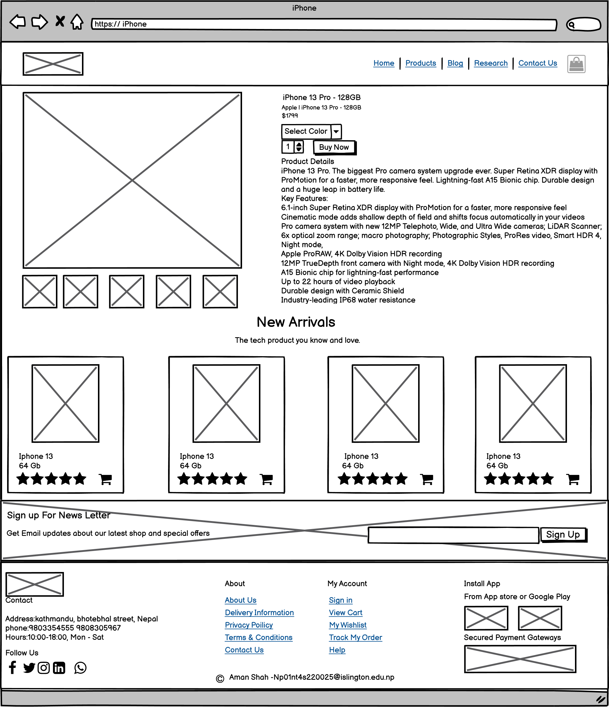

Figure 6 Wireframe of Single product page

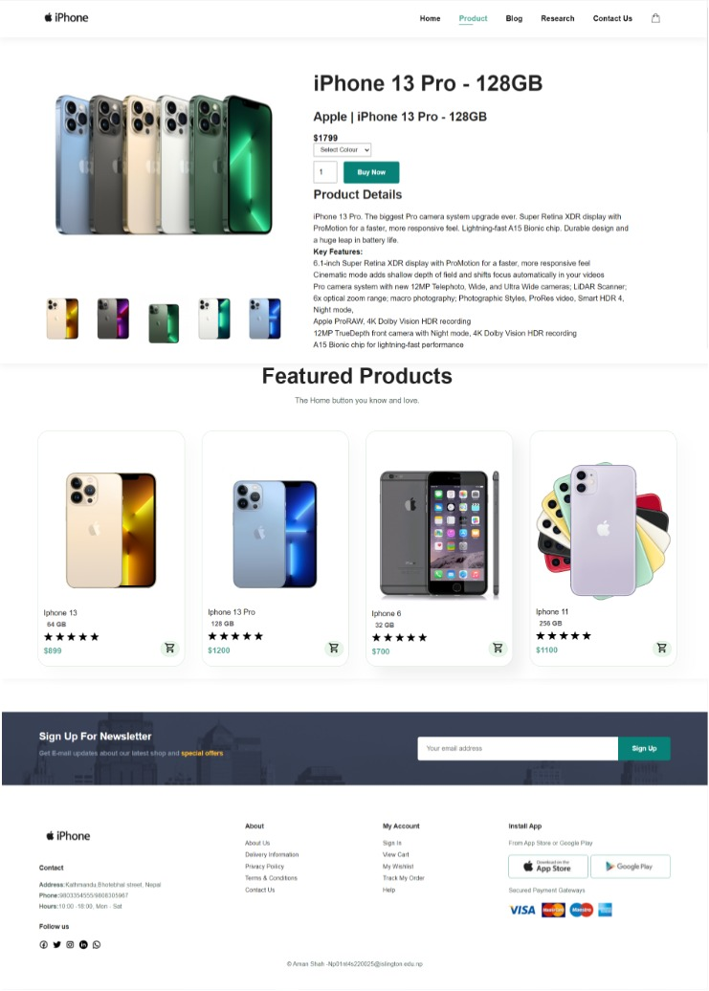

Figure 7 Screenshot of Single product page

## 2.6 Blog Page

A blog (a shortened version of “weblog”) is an online journal or informational website displaying information (Minaev, 2022). It is a platform where a writer or a group of writers share their views on an individual subject (Minaev, 2022).

The Blog page of my website has a navigation bar which is helpful to go from one page to another page. The blog page has a banner below the navigation bar. The blog page has described the positive and negative effects of technology on my life. There are three positive and three negative effects of the technology described on the blog page. There is an image and a paragraph return to show the positive and negative effects. After that, we have a newsletter area where the customer can fill the form with their email so they get the new product arrival message the first. After that, we have a footer section where I have included various links and copyright details also. The blog page is divided into five sections that describe the flex properties to make the website responsive.

For the development of the Blog page, I have first designed our wireframe and made the website.

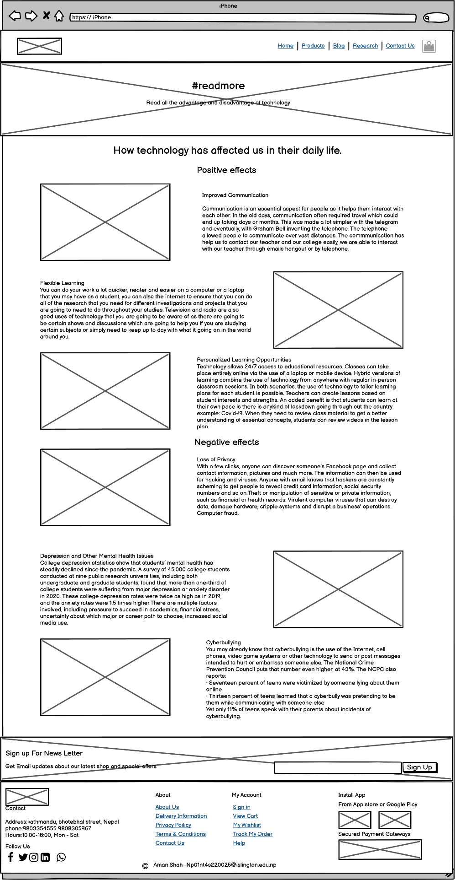

Figure 8 Wireframe of the Blog page

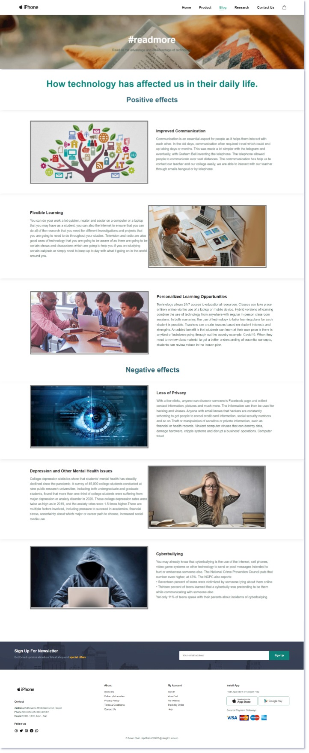

Figure 9 Screenshot of the Blog page

## 2.7 Research page

Research is defined as careful consideration of study regarding a particular concern or problem using scientific methods (Questionpro, 2022). According to the American sociologist Earl Robert Babbie, “research is a systematic inquiry to describe, explain, predict, and control the observed phenomenon (Questionpro, 2022).

The Research page of my website has a navigation bar which is helpful to go from one page to another page. The Research page has a banner below the navigation bar. The research page is made to know to give knowledge about the display and contrast the components used by me on my website against the website that is investigated for research purposes. Below the banner I have put the photo of the research and a paragraph defining what is research means, I have also included the marquee effect to make the website more attractive. After that, I have included the compare section where I have shown where I have taken the references and used the components in my website.

The website has five different compare sections and shows the references and where I have used them side by side with the photo. After that, we have a newsletter area where the customer can fill the form with their email so they get the new product arrival message the first. After that, we have a footer section where I have included various links and copyright details also.

For the development of the Research page, I have first designed our wireframe and made the website.

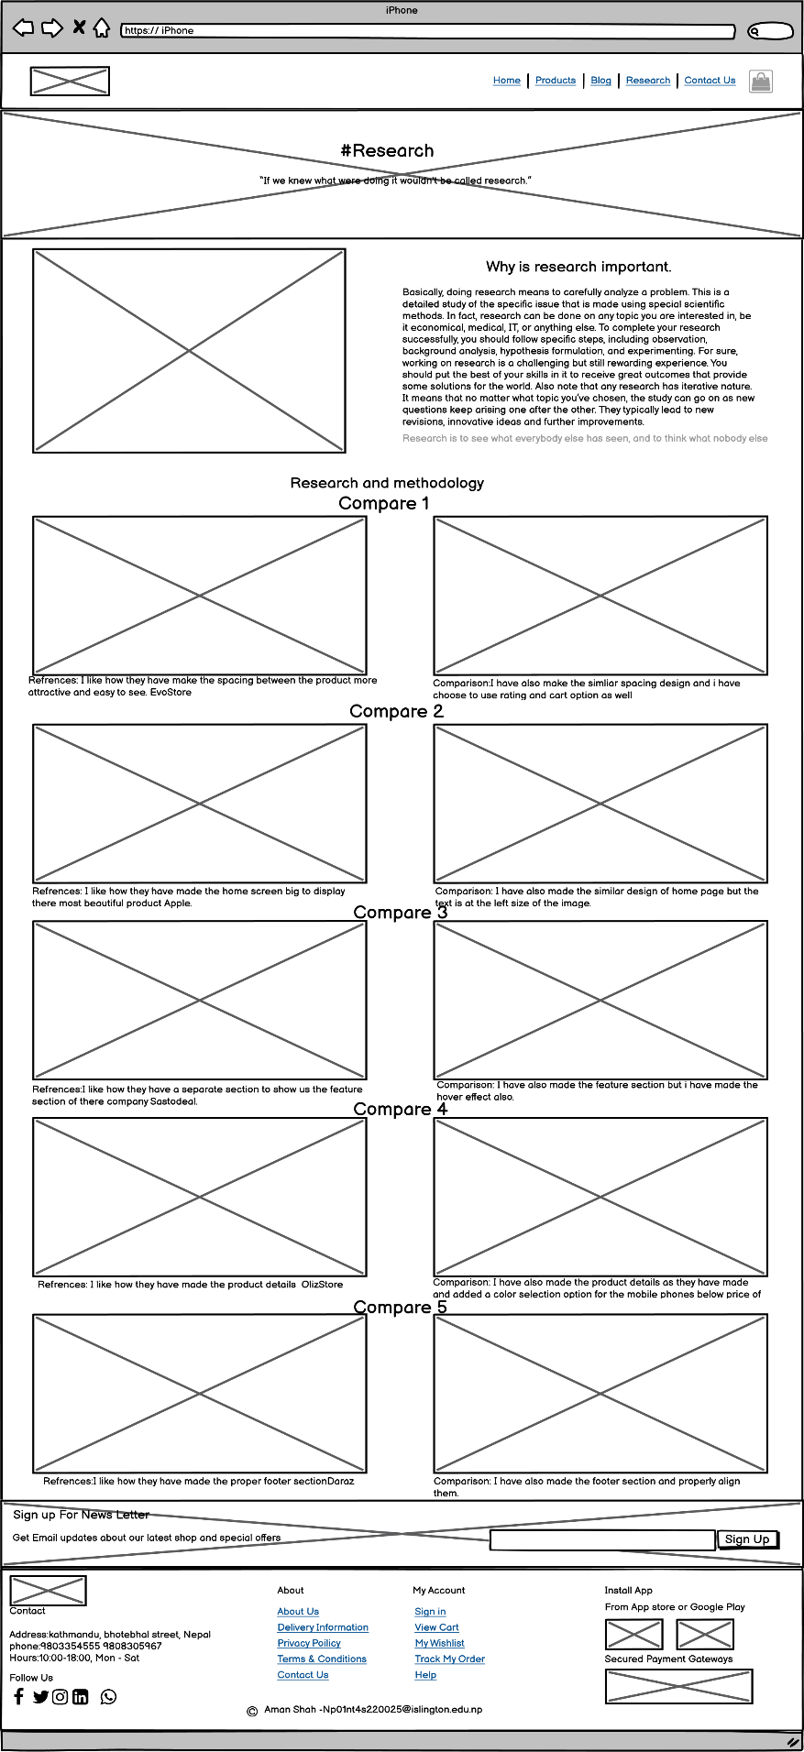

Figure 10 Wireframe of the Research page

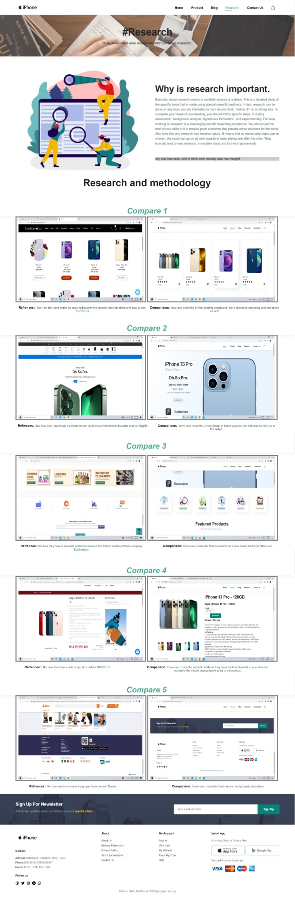

Figure 11 Screenshot of the Research page

## 2.8 Contact Us page

A contact form is a short web-based form published on a website (Broadley, 2022). Any visitor can fill out the form and submit it to send a message to the site owner (Broadley, 2022). Behind the scenes, your contact form triggers an email message to be generated and sent to your email inbox (Broadley, 2022). This lets you get messages from visitors easily without revealing your email address to spammers (Broadley, 2022).

The Contact Us page of my website has a navigation bar which is helpful to go from one page to another page. The Contact Us page has a banner below the navigation bar. After the banner, I have included contact us details if anyone wants to meet me in person. I have included a map on the right side and the left side, I have included the email, number, location, and when I will be at that location. Below that, I have included a JavaScript valid form on the left side and I have included my photo and details also on the right side. The form asks for the name, number, subject, email, and message to send.

After that, we have a newsletter area where the customer can fill the form with their email so they get the new product arrival message the first. After that, we have a footer section where I have included various links and copyright details also.

For the development of the Contact Us page, I have first designed our wireframe and made the website.

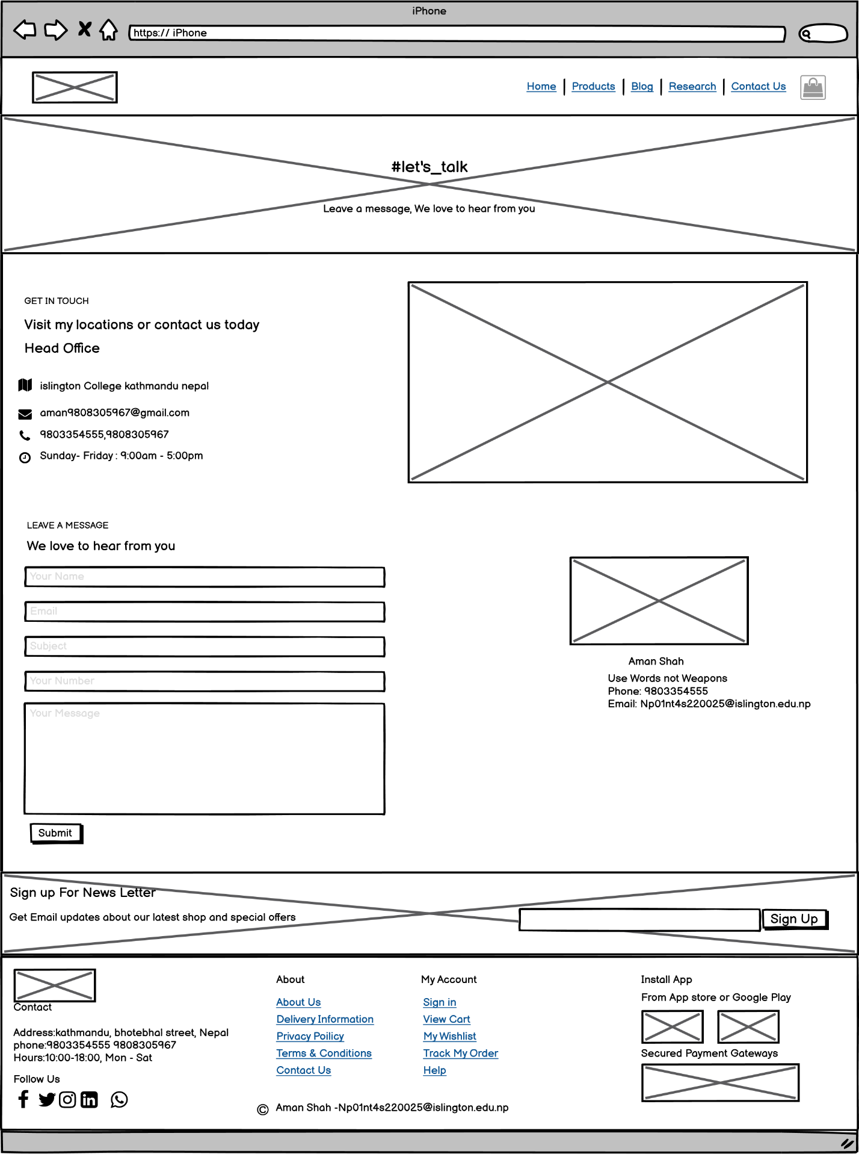

Figure 12 Wireframe of the Contact Us page

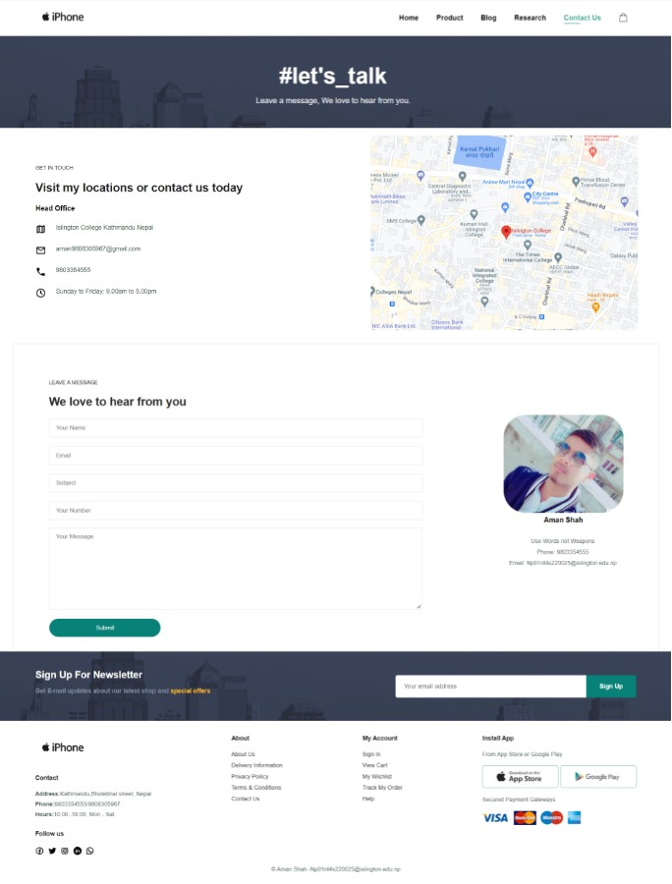

Figure 13 Screenshot of the Contact Us page

## 2.9 Cart page

A cart page is an essential part of an e-commerce website (Omniconvert, 2019). It is the page where users can pile up what they want to buy from the website and then simply checkout by paying online (Omniconvert, 2019). To comprehend what a cart page does, think of it as a normal shopping cart in a store (Omniconvert, 2019).

The Contact Us page of my website has a navigation bar which is helpful to go from one page to another page. The Contact Us page has a banner below the navigation bar. Below that, I have created a table to display the different types of heading as remove, image, product, price, quantity, and subtotal. The table shows three kinds of iPhones with their name, image, price, and quantity. After that, I uploaded an apply coupon section and besides that, I have included the cart total table. After that, we have a newsletter area where the customer can fill the form with their email so they get the new product arrival message the first. After that, we have a footer section where I have included various links and copyright details also.

For the development of the Cart page, I have first designed our wireframe and made the website.

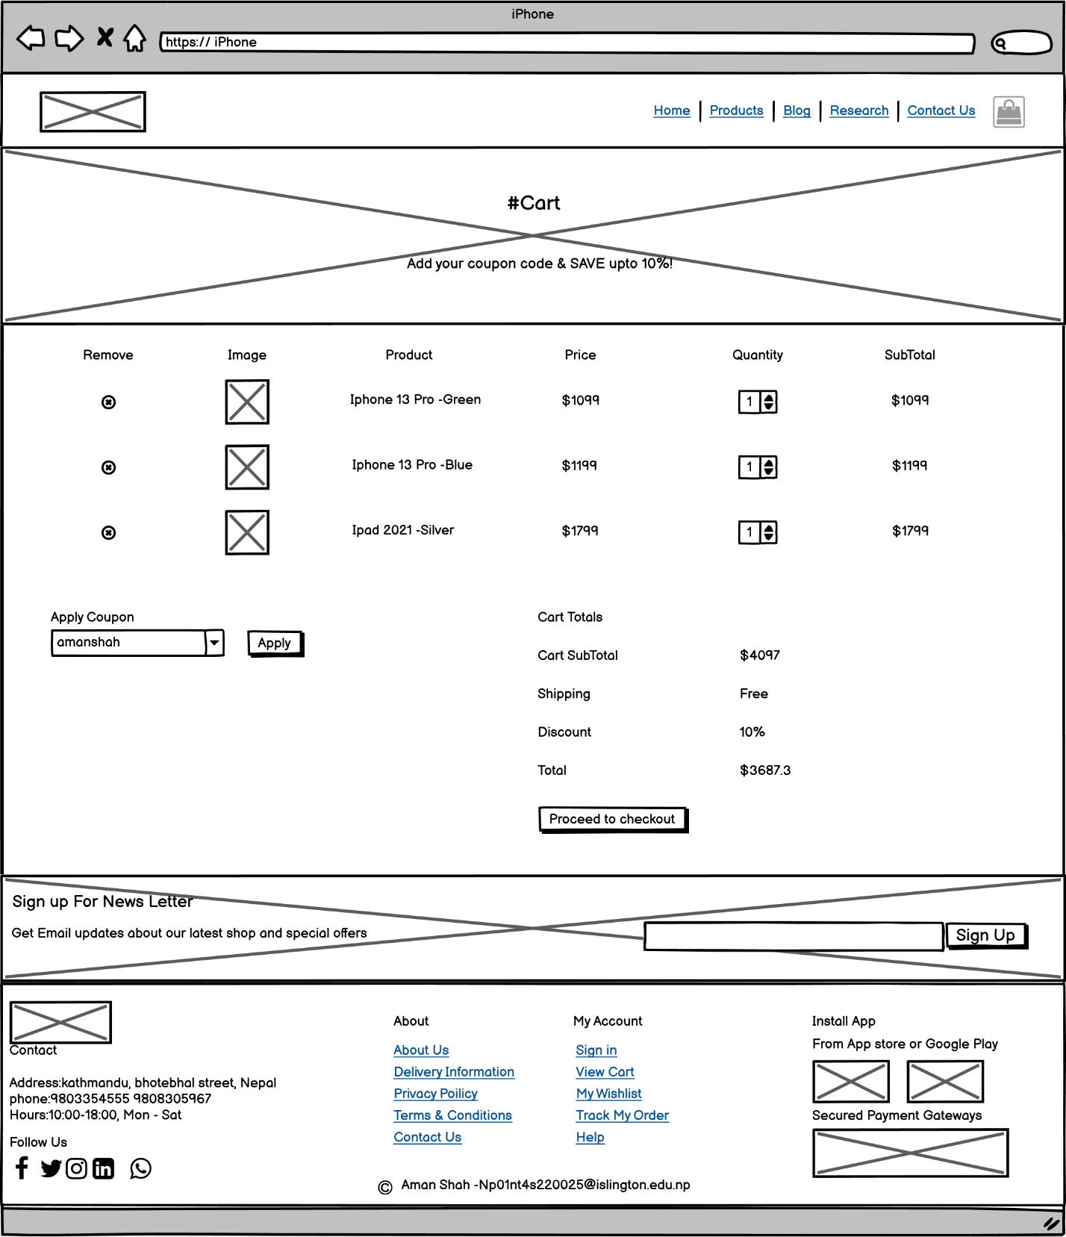

Figure 14 Wireframe of The Cart page

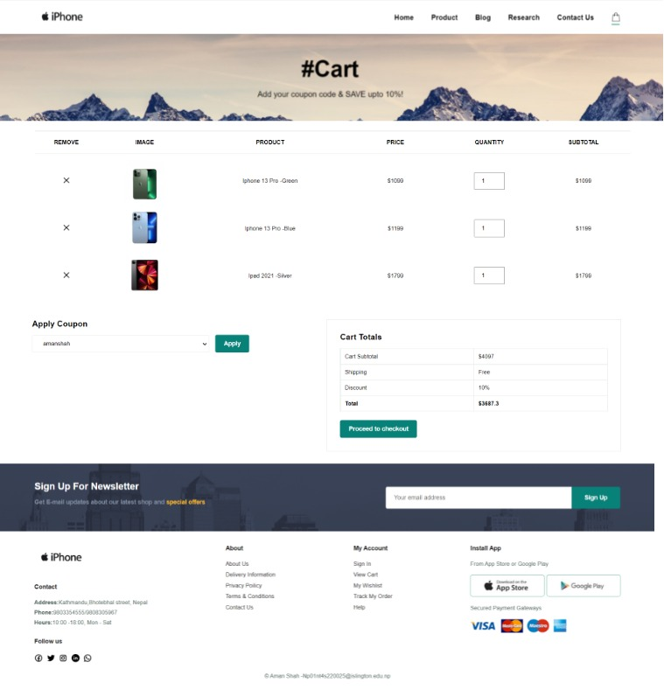

Figure 15 Screenshot of the Cart page

# **3. Testing**

Testing is the process to find out how our program is working.

3.1 Test 1**- To Check if the Date is working on the Homepage or not.**

|  |  |
| --- | --- |
| **Test No:** | **1** |
| Objective: | To check if the Date is working on the Homepage or not. |
| Action: | -Open the Home page on the website.  -Scroll Down to the newsletter Section. |
| Expected Result: | The time shown should be the same as the real world time and the timer should run like a real digital clock. |
| Actual Result: | The time shown is the same as the real world time and the timer is run like a real digital clock.  The result is marked with an arrow. |
| Conclusion: | The test is successful. |

Table 1 Test 1

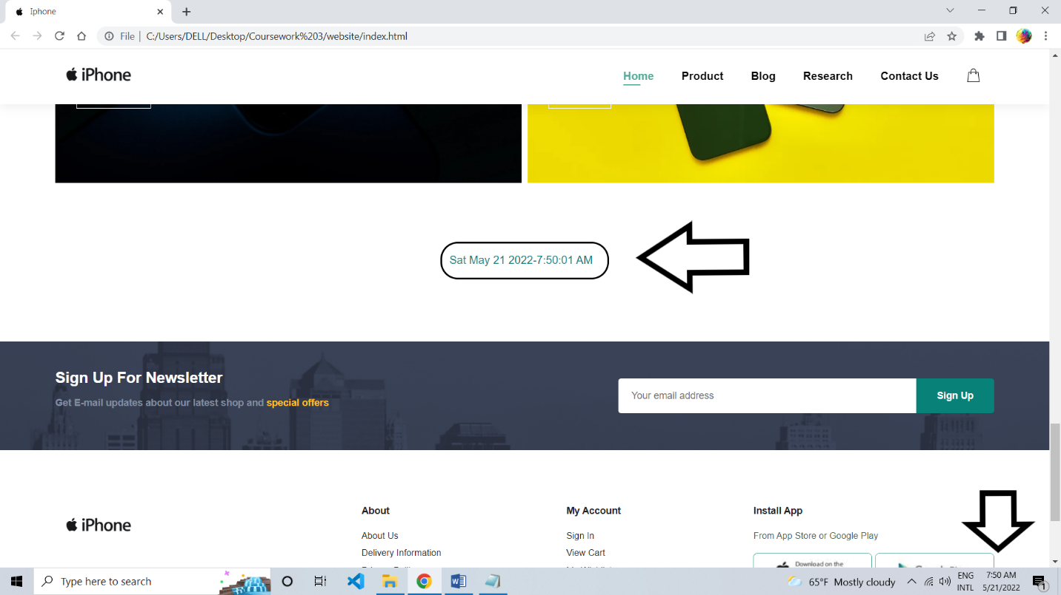

Figure 16 Screenshot of testing the date and time

3.2 Test 2**- To Check the Product image if we click another image.**

|  |  |
| --- | --- |
| **Test No:** | **2** |
| Objective: | To Check the Product image if we click another image. |
| Action: | -Open the Single product page on the website.  -Click on the blue color iPhone image |
| Expected Result: | The blue color image should be shown in the main image section. when we click the blue color image. |
| Actual Result: | The blue color image is shown in the main image section when we click the blue color image. |
| Conclusion: | The test is successful. |

Table 2 Test 2

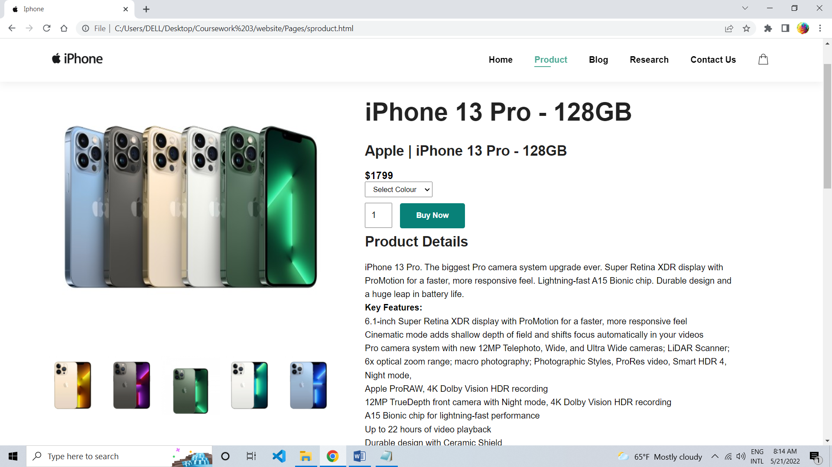

Figure 17 Screenshot of the main image of the Single product page

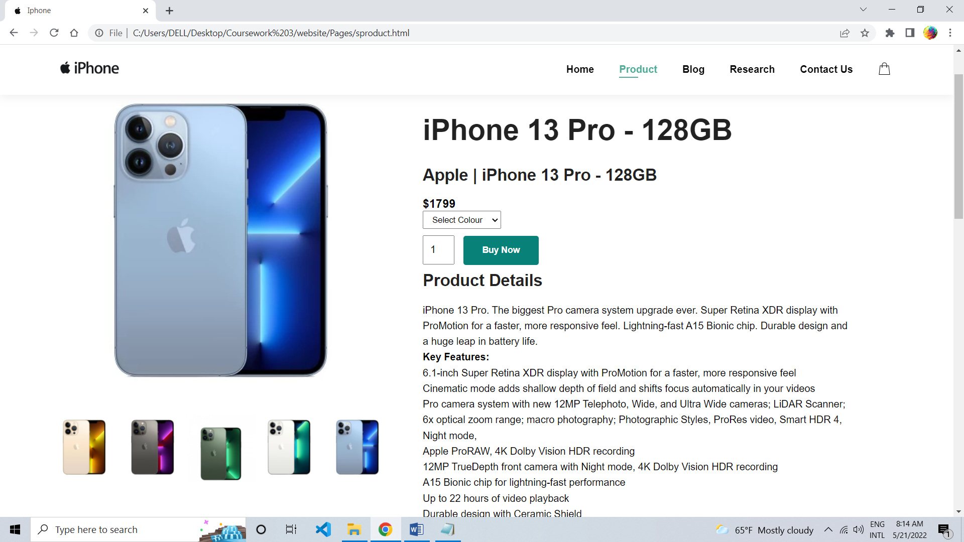

Figure 18 Screenshot of Change in the main image of Single product page

3.3 Test 3**- To Check Form Validation.**

|  |  |
| --- | --- |
| **Test No:** | **3** |
| Objective: | To Check Form Validation. |
| Action: | -Open the Contact Us page on the website.  -Fill up the Form  Your Name = Aman Shah  Email = [aman9808305967@gmail.com](mailto:aman9808305967@gmail.com)  Subject = Want a Job  Your Number = 9803354555  Your Message = Hello Sir, this is my CV please check it.  -Click on Submit Button |
| Expected Result: | The page will pop up with an alert message showing the message “Thank you for your feedback!!” |
| Actual Result: | The page is pop up with an alert message showing the message “Thank you for your feedback!!”. |
| Conclusion: | The test is successful. |

Table 3 Test 3

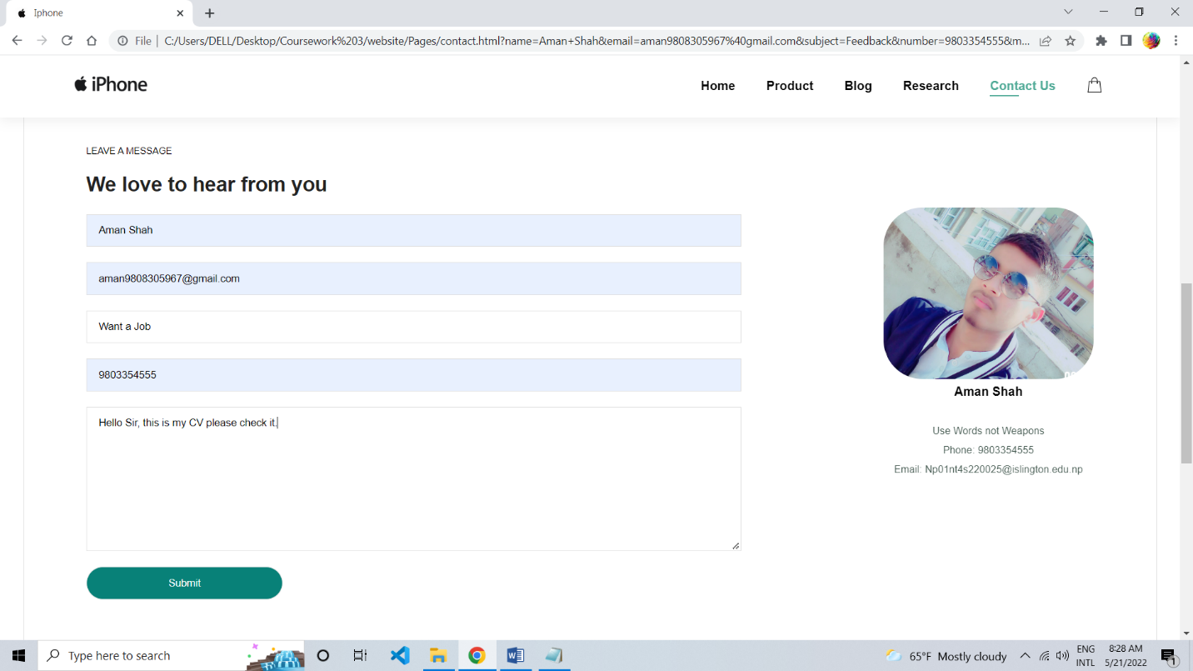

Figure 19 Screenshot of filling up the form.

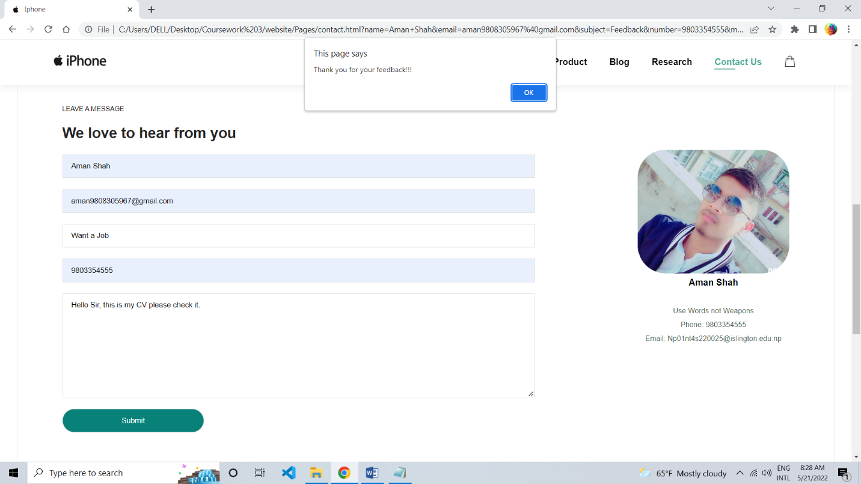

Figure 20 Screenshot of alert message.

3.4 Test 4**- To Check the Hover effect.**

|  |  |
| --- | --- |
| **Test No:** | **4** |
| Objective: | To Check the hover effect. |
| Action: | -Open the Home page on the website.  -Hover over the Blog page in the navigation bar.  -Click on the Blog Page |
| Expected Result: | When we hover over the blog page there will come a hover effect of green color and when we click on the blog page in the navigation bar it will redirect us to the blog page and there will be a hover effect to show on which page we are now at the navigation bar. |
| Actual Result: | When we hover over the blog page there is a hover effect of green color and when we click on the blog page in the navigation bar it redirects us to the blog page and there is a hover effect to show on which page we are now at the navigation bar. |
| Conclusion: | The test is successful. |

Table 4 Test 4

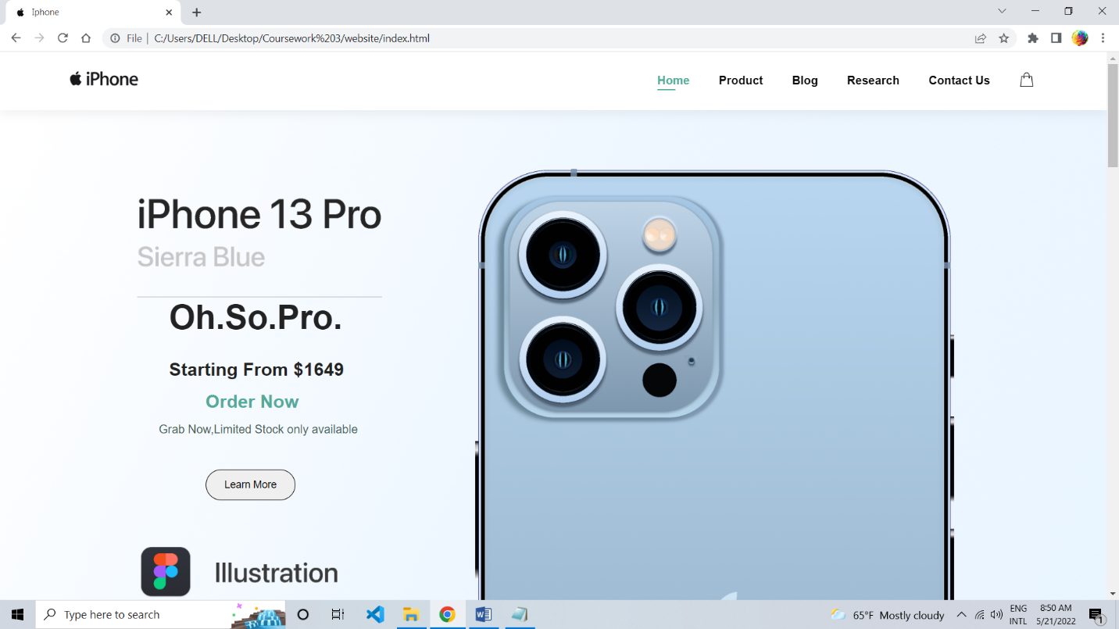

Figure 21 Screenshot of the navigation bar of the home page

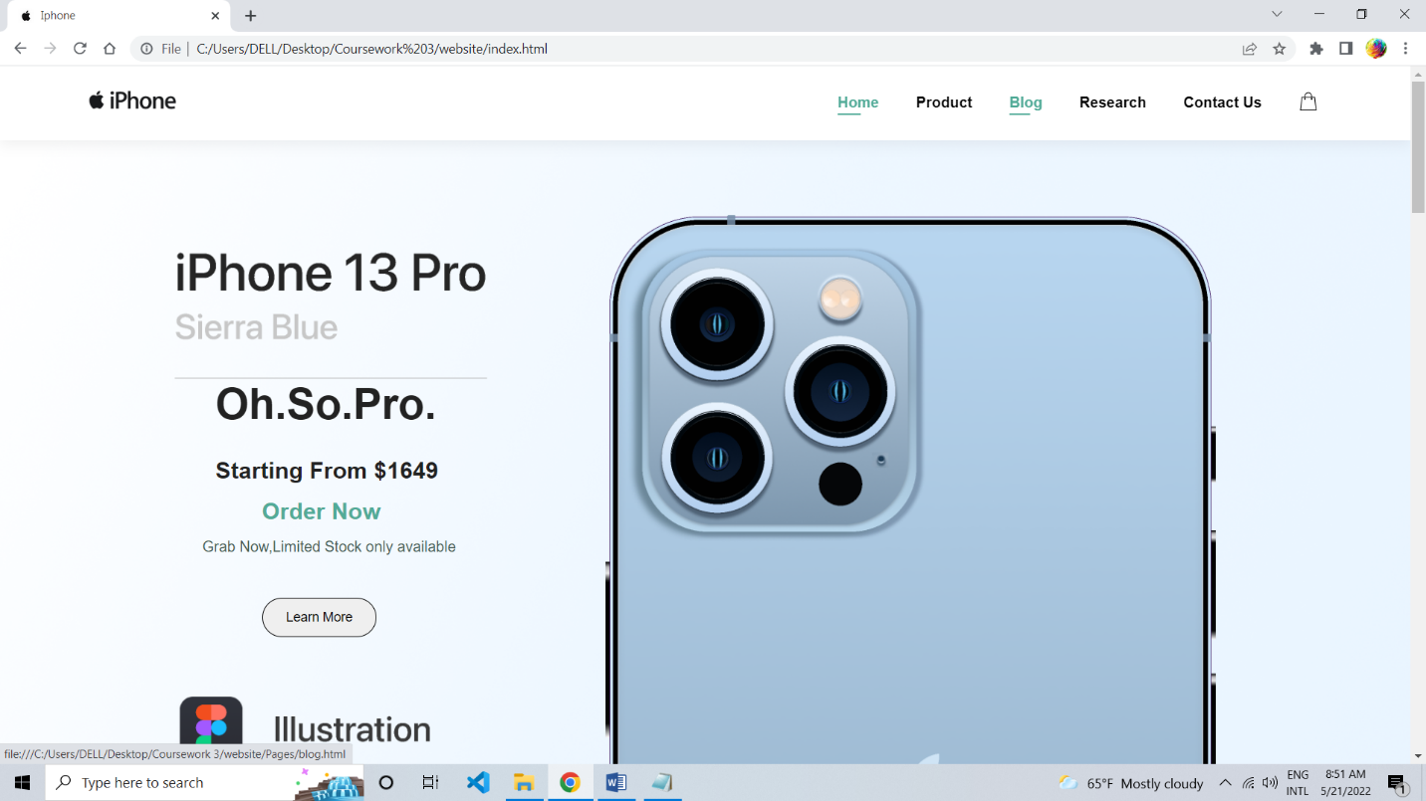

Figure 22 Screenshot of hover effect navigation bar

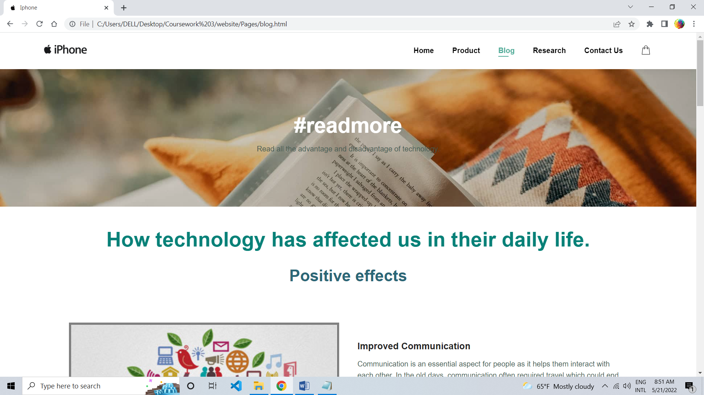

Figure 23 Screenshot of the navigation bar on the Blog page

3.5 Test 5**- To Check the internal and external links.**

|  |  |
| --- | --- |
| **Test No:** | **5** |
| Objective: | To check the internal and external links. |
| Action: | -Open the Home page on the website.  For internal link  -Click on the product page in the navigation bar.  For external link  -Click on the Facebook image in the footer section. |
| Expected Result: | When clicking on the product at the navigation bar we will be redirected to the product page website. And when we click on the Facebook image we will be redirected to my Facebook page. |
| Actual Result: | When clicked on the product at the navigation bar we are redirected to the product page website. And when we click on the Facebook image we are redirected to my Facebook page. |
| Conclusion: | The test is successful. |

Table 5 Test 5

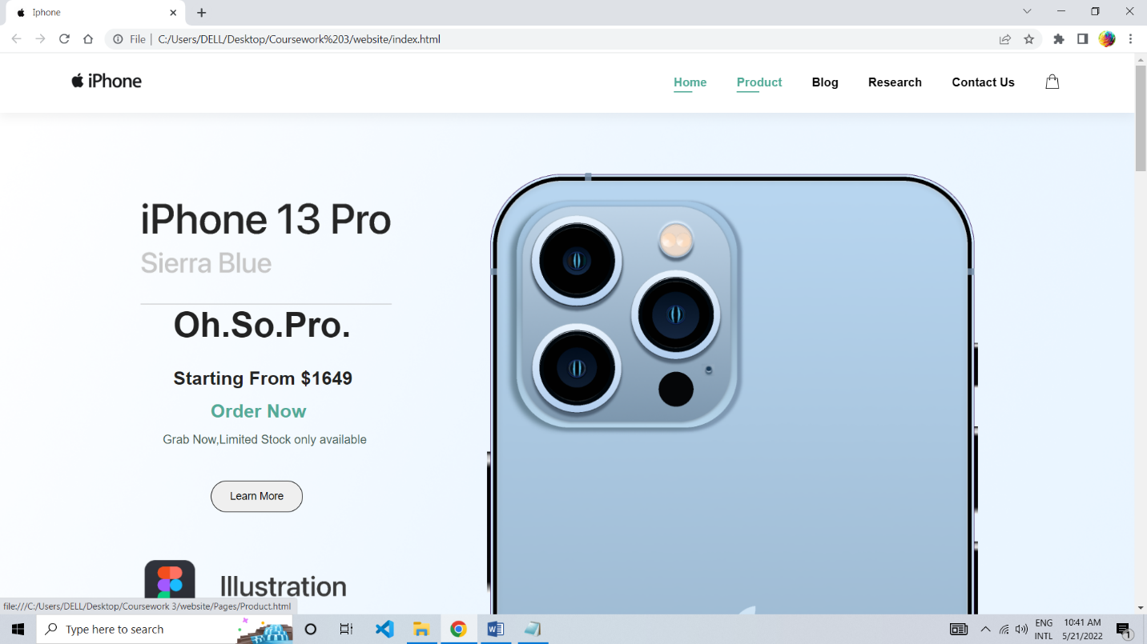

Figure 24 Screenshot of clicking the product page

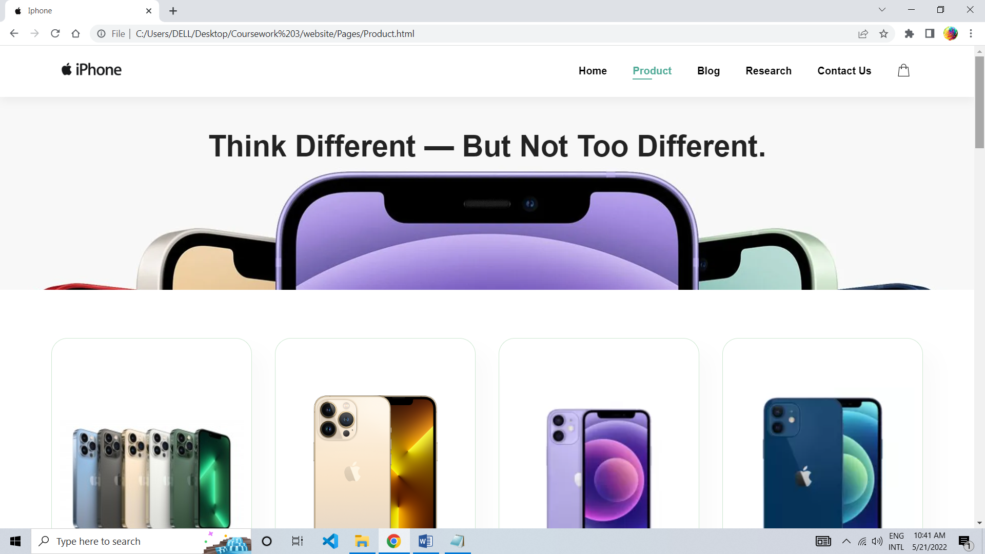

Figure 25 Screenshot of redirected to the product page

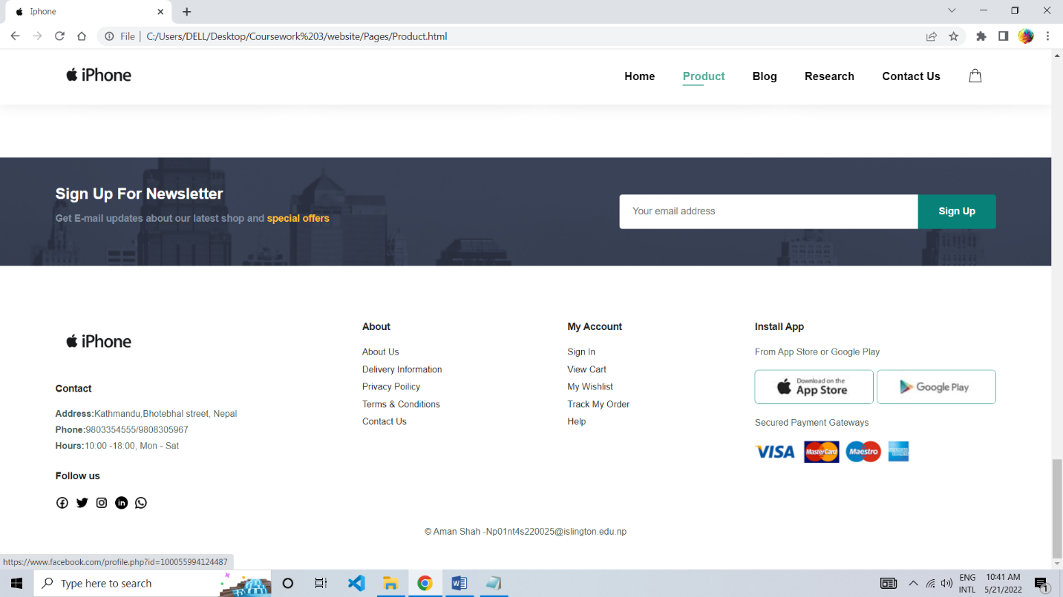

Figure 26 Screenshot of clicking the Facebook image at the footer section

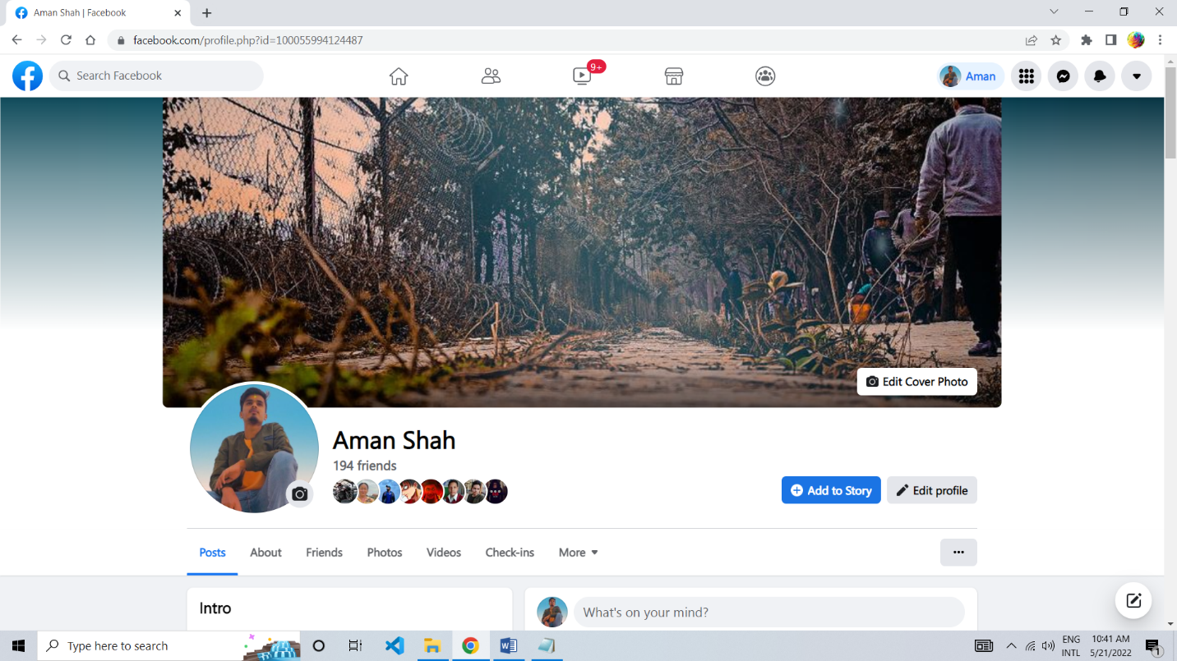

Figure 27 Screenshot of redirected to the Facebook

# **4. Conclusion**

While doing this coursework I have to face many problems with the code editor and using a wireframe. As it was very difficult to attach all the photos of a single website page on a single image so I have to break down the page into many sections and join all the section images in draw.io and make the single-page website image. The Tools that are used while creating this website are Visual studio code, Balsamiq, Chrome, and draw.io. The chrome browser has helped me as I was using a live server extension in VS Code.

This coursework required a lot of research as I had limited knowledge about JavaScript. At first, I was having difficulty creating a Website but this coursework has helped me to know more about HTML, CSS, and JavaScript and taught me how to create my website. As I learned HTML and CSS before starting college I was much familiar with them but JavaScript was completely new to me. I learned how to use flex properly while making this coursework. I also learned why it is important for a store to be online and why it is necessary for today’s world and how technology has affected us positively and negatively. I would like to thank our tutor Mr. Bijay Gautam sir for always being there for us and helping us in the correction of the errors we faced while doing this coursework.

Lastly, this coursework was a great opportunity that made me do more research which widen my overall knowledge about Web development. It made me re-learn the

understanding of HTML, CSS, and JavaScript. It also made me revise the lecture, tutorial, and lab classes respectively.

# **Appendix**

Originality Test

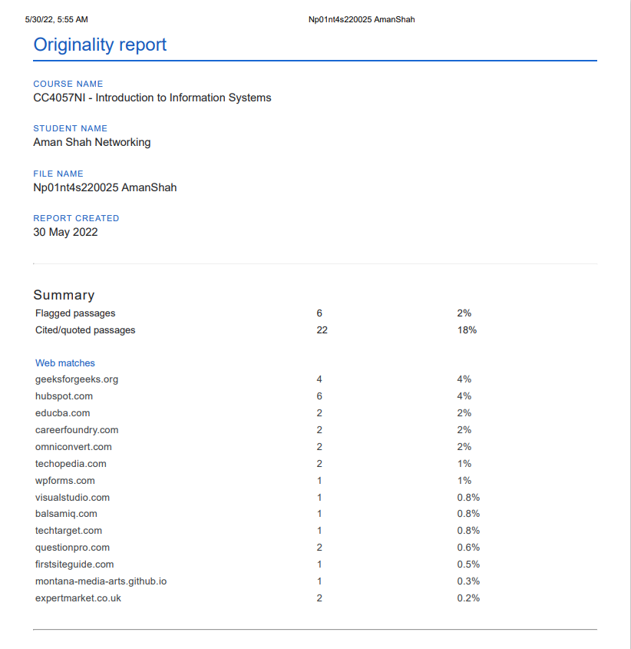

Figure 28 Originality Test

# **References**

Balsamiq, 2022. *Balsamiq.* [Online]   
Available at: https://balsamiq.com/wireframes/#:~:text=Balsamiq%20Wireframes%20is%20a%20rapid,come%20later%20in%20the%20process.  
[Accessed 18 May 2022].

Broadley, C., 2022. *Wpforms.* [Online]   
Available at: https://wpforms.com/8-reasons-why-you-need-a-contact-form/  
[Accessed 20 May 2022].

Cox, L. K., 2021. *blog.hubspot.* [Online]   
Available at: https://blog.hubspot.com/marketing/web-design-html-css-javascript  
[Accessed 16 May 2022].

Geeksforgeeks, 2021. *Geeksforgeeks.* [Online]   
Available at: https://www.geeksforgeeks.org/what-is-a-website/  
[Accessed 14 May 2022].

HANNAH, J., 2021. *Careerfoundry.* [Online]   
Available at: https://careerfoundry.com/en/blog/ux-design/what-is-a-wireframe-guide/  
[Accessed 17 May 2022].

Minaev, A., 2022. *First Site Guide.* [Online]   
Available at: https://firstsiteguide.com/what-is-blog/  
[Accessed 20 May 2022].

Omniconvert, 2019. *Omniconvert.* [Online]   
Available at: https://www.omniconvert.com/what-is/cart-page/#:~:text=A%20cart%20page%20is%20an,simply%20checkout%20by%20paying%20online.  
[Accessed 20 May 20222].

Pedamkar, P., 2019. *Educba.* [Online]   
Available at: https://www.educba.com/what-is-visual-studio-code/  
[Accessed 17 May 2022].

Questionpro, 2022. *Questionpro.* [Online]   
Available at: https://www.questionpro.com/blog/what-is-research/  
[Accessed 20 May 2022].

Sharpened Productions, 2022. *Techterms.* [Online]   
Available at: https://techterms.com/definition/home_page  
[Accessed 19 May 2022].

Techopedia, 2020. *Techopedia.* [Online]   
Available at: https://www.techopedia.com/definition/5411/website  
[Accessed 14 May 2022].

TechTarget, 2022. *TechTarget.* [Online]   
Available at: https://www.techtarget.com/whatis/definition/text-editor  
[Accessed 22 May 2022].

VelocityConsultancy, 2021. *VelocityConsultancy.* [Online]   
Available at: https://www.velocityconsultancy.com/importance-of-website-reasons-why-your-business-needs-it/  
[Accessed 16 May 2022].

Visual Studio Code, 2022. *Visual Studio Code.* [Online]   
Available at: https://code.visualstudio.com/docs  
[Accessed 17 May 2022].